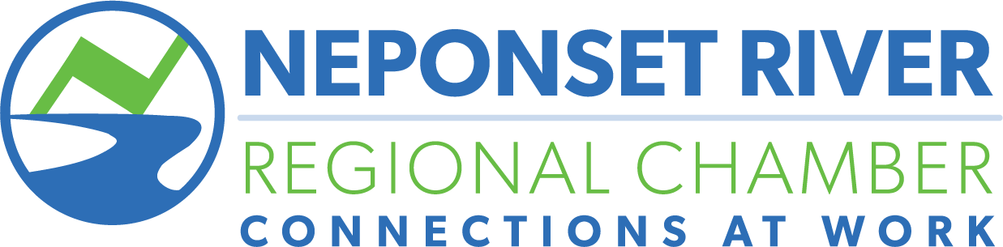

Awards Nomination Form

To be presented at the Annual Meeting in January 2024

Small Business of the Year
Presented to an NRRC Member Business that demonstrates outstanding achievement in general management, employee relations, business growth, business innovation, and community and social responsibility.
Large Business of the Year
Same criteria as above, but for a business of 50 employees or more.
Please check the award you wish to nominate the Member for, and fill out the required information below.
One nomination per form please.

Business Person of the Year
Presented to an individual whose personal guidance and leadership has made a positive contribution to the Neponset River region.

Paul Smith Award for
Outstanding Volunteerism
Presented to a volunteer who has
demonstrated an outstanding
commitment to the NRRC and its members, exemplified by the late Paul Smith, Sr. - selfless giving of time, talent and materials to help fellow members succeed.

Nominee: _____________________________________________________________________________________
Describe Nominee’s qualifications for award (add pages if needed): _____________________________________________________________________________________
_____________________________________________________________________________________
_____________________________________________________________________________________
_____________________________________________________________________________________
Your Name and Company: _____________________________________________________________________________________

Please email completed form to Karen Collins at karen@nrrchamber.com
Nomination deadline: December 22, 2023

